Client sign-off

Roblox – Make a Game!

Documents checked

* Project summary
* Business case
* Configuration map
* Schedule model

I confirm that the content of the project management documents listed above provides an accurate and adequate specification of the project requirements

Signed:

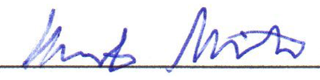

Date: 02/05/2020